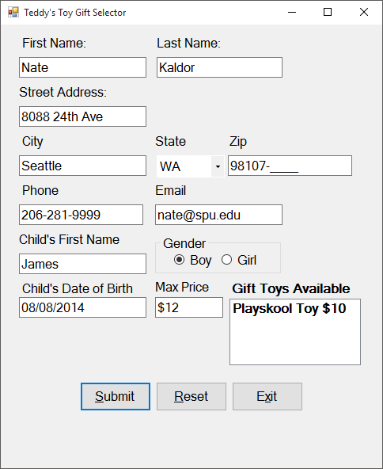

Boy born August 8, 2014, $12 price

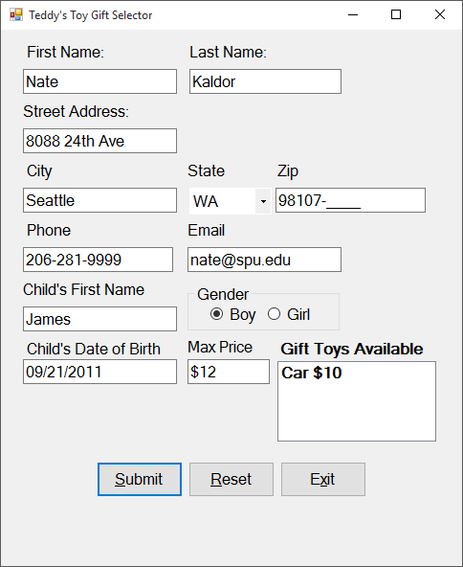

Boy born September 21, 2011, $12 price

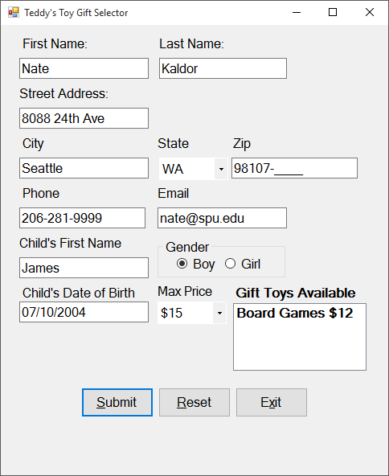

Boy born July 10, 2004, $15 price

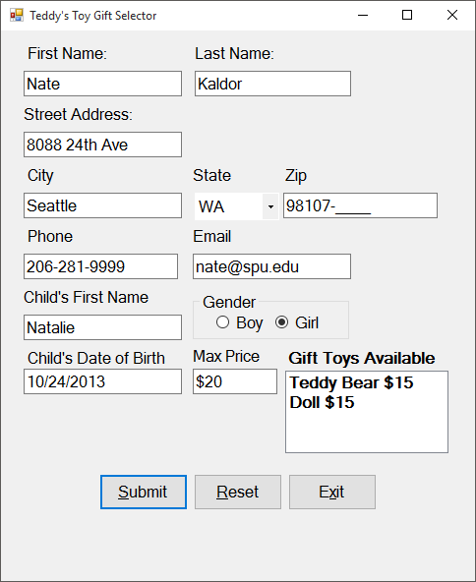

Girl born October 24, 2013, $20 price

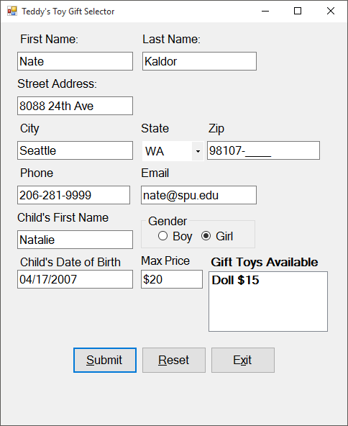

Girl born April 17, 2007, $20 price